K-Nearest Neighbours (KNN) with Euclidean Distance — 2D Example
This short tutorial shows how KNN classifies a new point using Euclidean distance in a simple 2D (x, y) setting.

1. What KNN does
KNN predicts the class of a new data point by looking at the K closest labelled points in the training set.

2. Euclidean distance in 2D
For A(x1, y1) and B(x2, y2):
d(A, B) = √((x2 − x1)² + (y2 − y1)²)

3. Worked example
Training data (labelled points):
Point | (x, y) | Class
A | (1, 1) | Red
B | (4, 1) | Blue
C | (2, 4) | Red

New point to classify: P = (3, 3)

4. Plot of the points
The figure below shows the training points and the new point P on the x–y plane.
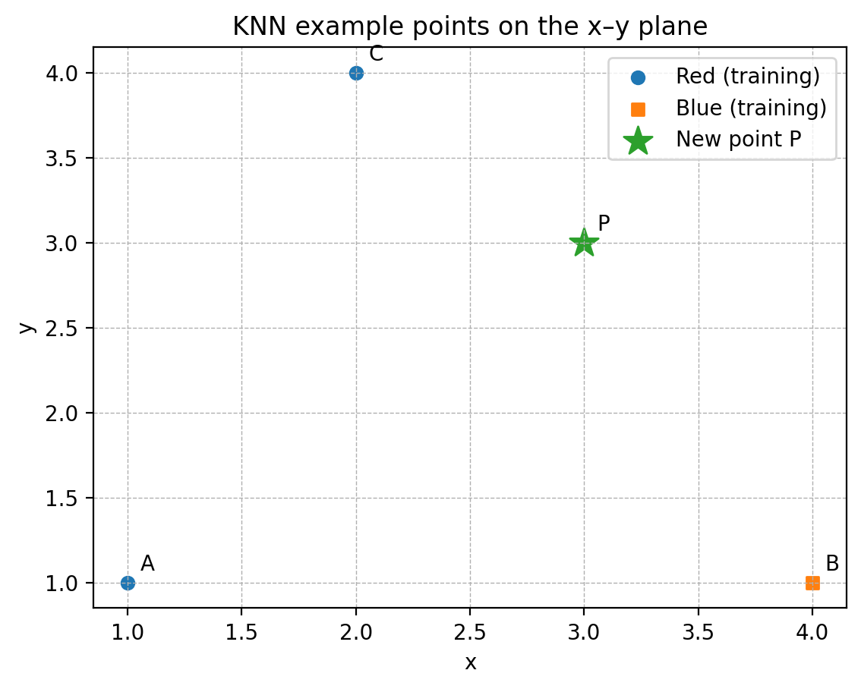

5. Step-by-step distance calculations
Compute the distance from P to each training point:
Distance to A (1, 1): d(P, A) = √((3 − 1)² + (3 − 1)²) = √((2)² + (2)²) = √(8) = 2.83
Distance to B (4, 1): d(P, B) = √((3 − 4)² + (3 − 1)²) = √((-1)² + (2)²) = √(5) = 2.24
Distance to C (2, 4): d(P, C) = √((3 − 2)² + (3 − 4)²) = √((1)² + (-1)²) = √(2) = 1.41

6. Sort neighbours (nearest first)
After computing distances, sort points from smallest distance to largest:
Point | (x, y) | Class | Distance to P
C | (2, 4) | Red | 1.41
B | (4, 1) | Blue | 2.24
A | (1, 1) | Red | 2.83

7. Choose K and predict
K = 1: Use the single nearest neighbour. The class of the nearest point becomes the prediction.
K = 3: Use the three nearest neighbours. The predicted class is the majority vote among them.
For this example:
• K = 1 → nearest neighbour is C → predict Red
• K = 3 → votes: Red = 2 (A and C), Blue = 1 (B) → predict Red

8. Practice question
Try this yourself:
Training points:
• D (0, 0) Class = Blue
• E (3, 0) Class = Red
• F (0, 4) Class = Blue
New point: Q = (2, 3)
Tasks:
1) Compute d(Q, D), d(Q, E), d(Q, F) using Euclidean distance
2) Sort the distances (nearest to farthest)
3) Predict the class for K = 1 and K = 3

Student practice (no solutions)
Complete the tasks below using the Euclidean distance formula. Show your working clearly. Do not use a calculator unless your tutor allows it.

Exercise 1: K = 1 and K = 3 (classification)
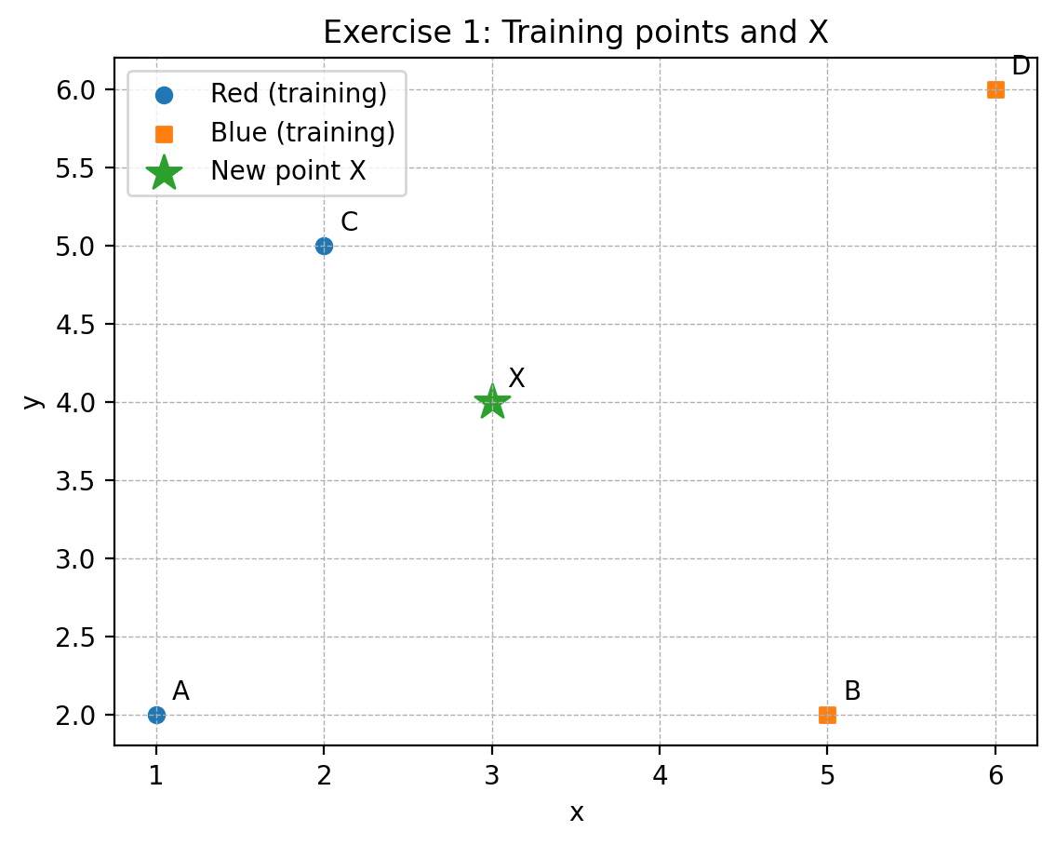
Figure: Exercise 1 points (use this to calculate distances).
Training points (labelled):
• A (1, 2) Class = Red
• B (5, 2) Class = Blue
• C (2, 5) Class = Red
• D (6, 6) Class = Blue
New point to classify: X = (3, 4)
Tasks:
1) Compute the distance from X to A, B, C and D.
2) Sort the points from nearest to farthest.
3) Predict the class of X when K = 1.
4) Predict the class of X when K = 3.
5) (Challenge) What happens if K = 2? Explain how you would handle a tie.

Exercise 2: Regression (predict a number)
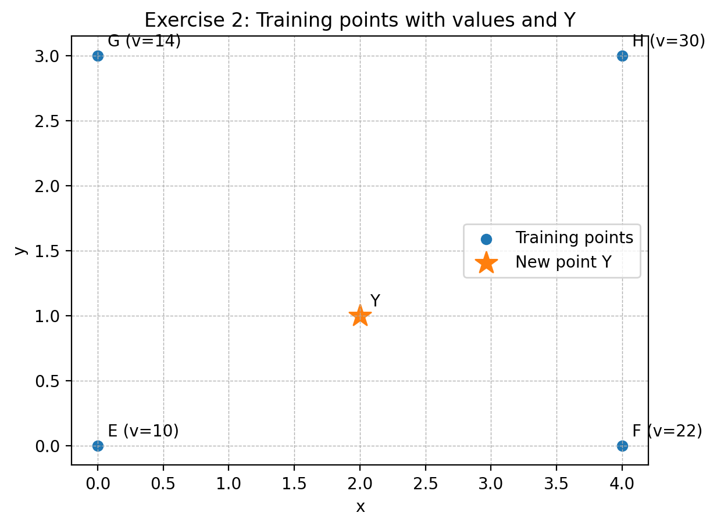
Figure: Exercise 2 points (use this to calculate distances and predict a value).
In KNN regression, the prediction is usually the average of the target values of the K nearest neighbours.
Training points with a numeric value (target):
• E (0, 0) Value = 10
• F (4, 0) Value = 22
• G (0, 3) Value = 14
• H (4, 3) Value = 30
New point: Y = (2, 1)
Tasks:
1) Compute the distance from Y to E, F, G and H.
2) Identify the 2 nearest neighbours (K = 2).
3) Predict the value at Y by taking the average of the two nearest values.

Exercise 3: Feature scaling (concept question)
KNN uses distances, so features with large numeric ranges can dominate the distance.
Answer in 2–3 sentences:
If one feature is measured in kilograms (0–100) and another in millimetres (0–100000), why might KNN perform poorly without scaling? What is one common scaling method?

